AdConcierge
(External AD Serving Capabilities – Campaign Replicator)
(Twitter to Facebook)
Low Level Design Specification Document
Version No. 0.0



 | Prepared By | Reviewed by | Approved By
Name | Arunachalam P
Role | SA
Signature
Date | 09 – Aug – 2017

Table of Contents
1.0 Introduction 3
1.1 Purpose of this document 3
1.2 Scope 3
1.3 Intended Audience 3
1.4 Definition & Acronyms 3
1.5 References 3
2.0 Conventions and Standards Followed 4
3.0 Assumptions, Dependencies and Constraints 5
3.1 Assumptions 5
3.2 Dependencies 5
3.3 Constraints 5
4.0 Use Case Realization 6
4.1 Flow of Events – Design 6
4.2 Derived Requirements 6
5.0 Package Design - Common Parser 7
5.1 Design Process 7
5.2 Component Details 8
6.0 References 9
7.0 Change Log 10

Introduction

Purpose of this document
The detailed design contains the design of every module / sub-system. This covers the following:
- Design of common / generic components
- Module / Sub-system design
- Unit / Class / Program Specifications
From a content consideration, the above three have been combined in this document. However, depending on the scale of design or projects, from manageability and configurability point of view, the above three may be split and maintained.

Scope
The scope of this process is to give detail understanding of how the parser is implemented and how the same will be used for parsing data during replication.

Intended Audience
The intended audience for this document is
- Developers, testers, other associates in the project
- Delivery Assurance Group, Process Engineering group

Definition & Acronyms
NA

References

Conventions and Standards Followed
Coding conventions are style guidelines for programming. They typically cover:
- Naming and declaration rules for variables and functions.
- Rules for the use of white space, indentation, and comments.
- Programming practices and principles
Coding conventions secure quality:
- Improves code readability
- Make code maintenance easier
Coding conventions can be documented rules for teams to follow, or just be your individual coding practice.

Assumptions, Dependencies and Constraints

Assumptions
The system is enhanced with process of replicating campaign within same network or different network. This process will replicate the campaign details and its lineItems details alone.

Dependencies
This replication process dependent on AdTech wrapper services and OcLazyLoad, where campaign details are being fetched by the wrapper services and campaign page rendering will be done via Oclazyloader respectively.

Constraints
Describe any global limitations or constraints that have a significant impact on the design of the system's software (and describe the associated impact). Such constraints may be imposed by any of the following (the list is not exhaustive):
- Hardware or software environment
- End-user environment
- Availability or volatility of resources
- Standards compliance
- Interoperability requirements
- Interface/protocol requirements
- Data repository and distribution requirements
- Security requirements (or other such regulations)
- Memory and other capacity limitations
- Performance requirements
- Network communications
- Verification and validation requirements (testing)
- Other means of addressing quality goals
- Other requirements described in the requirements specification

Package Design - Common Parser
The parser is key functionality of this replication process. The required field details can be fetched from the twitter by passing the parameter to the parser and parser get the destination field mapping from configuration file. After getting the field mapping detail, it will be send back to parser, where it iterates through the local storage parameter named, “CampaignData” (which holds the full campaign details) and value will be fetched.

Component Details

Name | Brief Description | Path
ReplicatorParser.js | This parser will have function to do find the filed mapping, iterating data to find the value of mapped fields and routing to respective pages | ..\webapps\CNAP_UI_Repo\app
ReplicatorConfig.js | This configuration file contains the field mapping details by networks and by objectives and routing details of each steps to navigate between the steps while replicating the campaign.  Also it should be defined objective mapping of each network with a common name. | ..\webapps\CNAP_UI_Repo\app

From the summary page, once user decided to replicate when Go Live, the functionality of the parser starts, the same have been explained in details below in step by step manner,

Step 1: setParser () function will be called with source network and objectiveName as parameters.

Function setParser (SourceNetwork, ObjectiveName) {
obj. twitterParser= function () {
……………………………..
}
}

Step 2: Parser then identify the corresponding facebook objective from the configuration file which we already defined as object [objectiveMapping] for each network.

var objectiveMapping = [
"Engagement" = {
"facebook":['Boost your posts','Promote your Page','Raise attendance at your events'],
"twitter":['Tweet engagements'],
},
"Reach" = {
"facebook":['Reach People near your Business'],
"twitter":['Followers'],
},
"Awareness" = {
"facebook":['Increase Brand Awareness'],
"twitter":['Awareness'],
},
"Website visits" = {
"facebook":['Send people to your Website'],
"twitter":['Website visits'],
},
"Video Views" = {
"facebook":['Get video views'],
"twitter":['Video views'],
},
"Leads" = {
"facebook":['Collect leads for your business'],
"twitter":[],
},
"App Installs" = {
"facebook":['Get installs of your app'],
"twitter":['App installs'],
},
"Conversions" = {
"facebook":['Increase conversions on your website'],
"twitter":[],
}
]

Step 3: After identified the corresponding facebook objective, parser will fetch the source network (twitter network) field mapping details from the configuration file(ReplicatorConfig.js).
var fieldMapping = [
"facebook" = {
"Boost Your Post" = {
"campaign_name" : "~campaignId~.data.campaignDetails.name",
"objective" : "~campaignId~.data.campaignDetails.objective",
"adset_name" : "~adsetId~.data.adsets.name",
"Location":"~adsetId~.data.adsets.targeting.geo_locations",
"AgeMin":"~adsetId~.data.adsets.targeting.age_min",
"AgeMax":"~adsetId~.data.adsets.targeting.age_max",
"Language":"~adsetId~.data.adsets.targeting.locales",
"Gender":"~adsetId~.data.adsets.targeting.genders",
"daily_budget": "~adsetId~.data.adsets.daily_budget",
"lifetime_budget":"~adsetId~.data.adsets.lifetime_budget",
"schedule_start":"~adsetId~.data.adsets.start_time",
"schedule_end":"~adsetId~.data.adsets.end_time",
"Bid Amount" : "~adsetId~.data.adsets.bid_amount",
"is_autobid" : "~adsetId~.data.adsets.is_autobid==true?:bid_amount",
"pacing":"~adsetId~.data.adsets.pacing_type",
"targeting_devices":"~adsetId~.data.adsets.targeting.device_platforms"
"targeting_interest":"~adsetId~.data.adsets.targeting.interests",
"targeting_behaviors":"~adsetId~.data.adsets.targeting.behaviors",
"targeting_demographics":"~adsetId~.data.adsets.targeting.user_adclusters"
}
},
"twitter" = {
"Tweet Engagement" - {
"campaign_name" : "~campaignId~.data.campaign.name",
"objective" : "~lineItemdId~.data.lineItems.objective",
"daily_budget" : "~lineItemdId~.data.lineItems.daily_budget_amount_local_micro",
"lineItem_name" : "~lineItemdId~.data.lineItems.name",
"Gender":"~lineItemdId~.data.lineItems.account_targeting_criteria.~targetingCriteriaID~.targeting_type=='GENDER'?name",
"Location":"~lineItemdId~.data.lineItems.account_targeting_criteria.~targetingCriteriaID~.targeting_type=='LOCATION'?name",
"Language":"~lineItemdId~.data.lineItems.account_targeting_criteria.~targetingCriteriaID~.targeting_type=='LANGUAGE'?targeting_value",
"Bid Amount" : "~lineItemdId~.data.lineItems.bid_amount_local_micro",
"lifetime_budget":"~lineItemdId~.data.lineItems.total_budget_amount_local_micro",
"is_autobid" : "~lineItemdId~.data.lineItems.automatically_select_bid",
"schedule_start":"~lineItemdId~.data.lineItems..start_time",
"schedule_end":"~lineItemdId~.data.lineItems..end_time",
"AgeMin":"~lineItemdId~.data.lineItems.account_targeting_criteria.~targetingCriteriaID~.targeting_type=='AGE'?targeting_value",
"AgeMax":"~lineItemdId~.data.lineItems.account_targeting_criteria.~targetingCriteriaID~.targeting_type=='AGE'?targeting_value",
"pacing":"~campaignId~.data.campaign.standard_delivery",
"targeting_interest":"~lineItemdId~.data.lineItems.account_targeting_criteria.~targetingCriteriaID~.targeting_type=='INTEREST'?name",
"targeting_behaviors":"~lineItemdId~.data.lineItems.account_targeting_criteria.~targetingCriteriaID~.targeting_type=='BEHAVIORS'?name",
"targeting_platform":"~lineItemdId~.data.lineItems.account_targeting_criteria.~targetingCriteriaID~.targeting_type=='PLATFORM'?name"
}
}
]

Step 4: Parser now iterate the twitter campaign details from CampaignData which is in local storage, with the mapping details returned from the config.

Step 5: If config returned any conditional string, parser will identify the conditional string and fetch the data based on the condition.

"targeting_interest":"~lineItemdId~.data.lineItems.account_targeting_criteria.~targetingCriteriaID~.targeting_type=='INTEREST'?name",

Step 6: Values that’s are iterated from twitter campaign details will be stored in-memory as data object.

Step 7: Routing the control to FB details page by loading dependent file alone using lazy loader (ocLazyLoader)

$stateProvider.state('app.fbCampaignDetails', {
templateUrl: 'app/modules/facebookReplicator/campaigndetails.html',
url:"/fbCampaignDetails",
controller:'campaignController',
resolve: {
loadMyCtrl: ['$ocLazyLoad', function ($ocLazyLoad) {
console.log($ocLazyLoad);
return $ocLazyLoad.load('app/modules/facebookReplicator/campaigndetails.js');
}]
}
})

Step 6: In FB details page the parser’s getParsedObject() function will be called with required field as parameter (eg., Objective_name), to get the value.

obj.getParsedObject = function(requestedField){
var obj;
function traverse (jsonObj, category) {
}
return obj;
}

Step 7: getParsedObject() returns the value of requested field value by iterating the data object returned from setParser().

Step 8: FB details page controller will bind the returned value to the respective scope variable.

Twitter Field Mapping Details
Field Name | Reference Field Mapping
Campaign Name | campaign_name
Marketing Objective | objective
Gender | gender
Location | location
Language | language
Daily Budget | daily_budget
Total Budget | lifetime_budget
Choose Pricing | is_autobid
Schedule – Start Date | schedule_start
Schedule – End Date | schedule_end
Age | ageBucket
Pacing | Pacing
Placements | device_platforms
Detailed Targeting - Interest | targeting_interest
Detailed Targeting – Behaviors | targeting_behaviors
Detailed Targeting - Demographics | targeting_demographics

Use Case Realization

Flow of Events – Design
Replication starts when user says “Go Live”, where you will get the pop up asking for Replication. If “No”, then it’s BAU, if “Yes” then it will ask to select the network. Once network selected and say “Replicate”, there the actual replication process starts.

  - On saying “Replicate”, the control goes to the common parser.
  - Parser route the control to the details page of targeted network.
  - Details page make a request back to parser by passing required field details.
  - After parser receive the request from details page, it refers the configuration file for actual field mapping details of source network.

Then parser iterates the “CampaignData” which is stored locally with the field mapping details receives from the configuration file and get the values, then return back to details page.

While we creating a campaign, we have saved a complete campaign details in local storage with the name of “CampaignData”.
We will populate the same in each step and create the Campaign like create campaign flow.
Go Live (TW)

Replicator Y / N?

N
Parent Campaign Page (BAU)

Y
Network FB / TW?
TW
Wrapper services call for copy

Controller)

Request for
Parameter name FB
Identifying current and destination n/w
Create current n/w data object and store it in local storage
Remove the previously loaded js/css/view file
Routing to destination n/w details page

Common Parser (controller)

Controller)
ReplicatorConfig
Controller)
Request for field value

Initial / Final
Routing
Return the
Parameter name

FB Details Page
(enabled with lazy loader)

Fig: Replicator Flow Diagram from Twitter Summary Page to FB Details Page

Replication process

Parser should be injected in campaign steps controller (which is defined for page data processing) which was already defined as a factory in the replicatorParser.js. This will communicate in between the replicatorParser and [campaignSteps].js.

replicatorApp.controller("[campaignStepController]", ['$rootScope', '$scope', '$http', 'parser', function($rootScope, $scope, $http, parser) {

])

Each field will send request with requested field as a parameter to getter which is defined in parser. Getter will traverse the parsed Object which is stored in in-memory and it returns the field value to campaign page. The value should be assigned into the ng-model of the specific field which is returned by the parser.

Var obj1 = Parser.getParsedObject(common-mapping-name);

If returned value is empty, then those fields needs to be highlighted with this icon. On click on that message should be poped out saying that “This option chosen is Twitter is not available in Facebook. Please added your preferred value here.” This pop out will have option to close manual and auto hidden after 5 secs.

Facebook Details Page

campaigndetails.js
(controller)
Controller)
Request for
Parameter value
ReplicatorParser.js
FB Details Page
(enabled with lazy loader)

Returns the
Parameter value

replicatorApp.controller("campaignDetailsController", ['$rootScope', '$scope', '$http', 'parser', function($rootScope, $scope, $http, parser) {

………………….

])

While we replicating twitter to facebook, in details page we have 2 fields to populate from the twitter capaign. That is,
Campaign Name – Returned campaign will be auto filled in campaign name field and let user can change it.
Objective Type – Returned objective type is more than one, it will be enabled in the list objectives which user can select any one of the returned objective. If it is a single objective, it will be auto selected from the objecive list and other objectives should be freezed. If it multiple objective list just enable those objectives and let user can select it and other objectives should be freezed.

Var campaignName = Parser.getParsedObject(“campaign-name”);
Var objective= Parser.getParsedObject(“objective”);

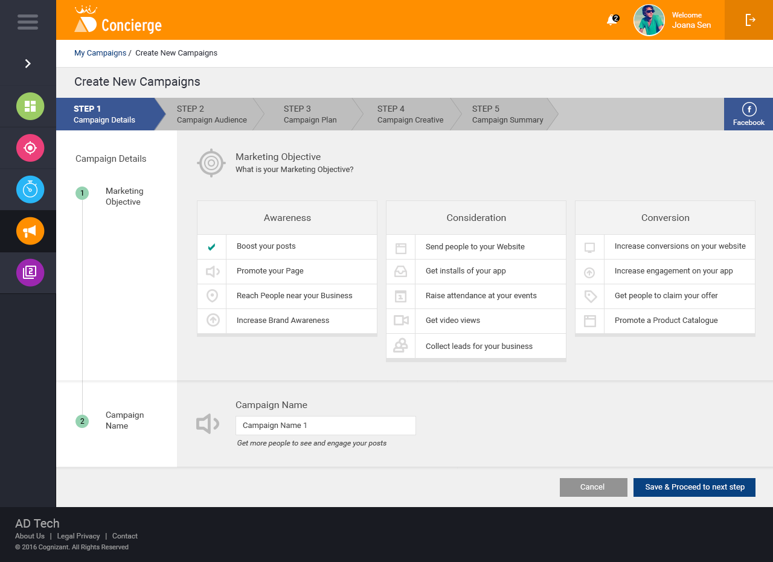

Facebook Audience Page

Request for
Parameter value
campaignaudience.js
(controller)
Controller)
ReplicatorParser.js
FB Audience Page
(enabled with lazy loader)

Returns the
Parameter value

replicatorApp.controller("campaignAudienceController", ['$rootScope', '$scope', '$http', 'parser', function($rootScope, $scope, $http, parser) {

])

In audience page,
Location – It is a mandatory field, returned location value will be auto filled in location field and user can add more locations.
Age – Age field is a mandatory field, age bucket will be returned from the common parser object and should split it into two part minAge and maxAge. Also It will be auto filled and let user can change it.
Languages – It is an optional field, if language is returned from the common parser object, it will be auto filled and let user can add more languages.
Placements – It is an optional field, if the parser return the placements, it should check with facebook placements, then it will be auto filled or not matched let use can select the placements.
detailed targeting – It is an optional field, facebook audience contains four type of details targeting
Demographics
Interests
Behaviours
facebook categories

And twitter also contains four type of detail targeting,
Interests
TV targeting
Behaviours
Event targeting

Searching mechanism of Detailed Targeting
- All the Interest, Behaviors, demographics and categories targeting values are derived from the services and same will be stored in corresponding array and populated all the targeting details with search option. The corressponding array name is as follows,
  - DemographicLeafDetails
  - InterestsLeafDetails
  - BehaviorsLeafDetails
  - MoreLeafDetails
- In page level controller (campaignAudience.js), we need to get each twitter detailed targeting from the parser and search (here we can use filter option to fetch from the array) the corressponding facebook detailed targeting which was populated from the services. If available, it should be auto filled. If its not available, let user can select the detailed targeting.

mobile-careers – It is also an optional field, if the parser return the mobile devices names, it should check with facebook mobile devices, then it will be auto filled or not matched let use can select the mobile device.

Var location = Parser.getParsedObject("locations”);
Var age = Parser.getParsedObject(“age”);
Var language = Parser.getParsedObject(“language”);
Var placements= Parser.getParsedObject(“placements”);
Var targetingInterest = Parser.getParsedObject("targeting_interest”);
Var targetingBehaviors= Parser.

(“targeting_behaviors”);
Var targetingEvents= Parser.getParsedObject(“targeting_events”);
Var tvTargeting= Parser.getParsedObject(“targeting_tvTargeting”);

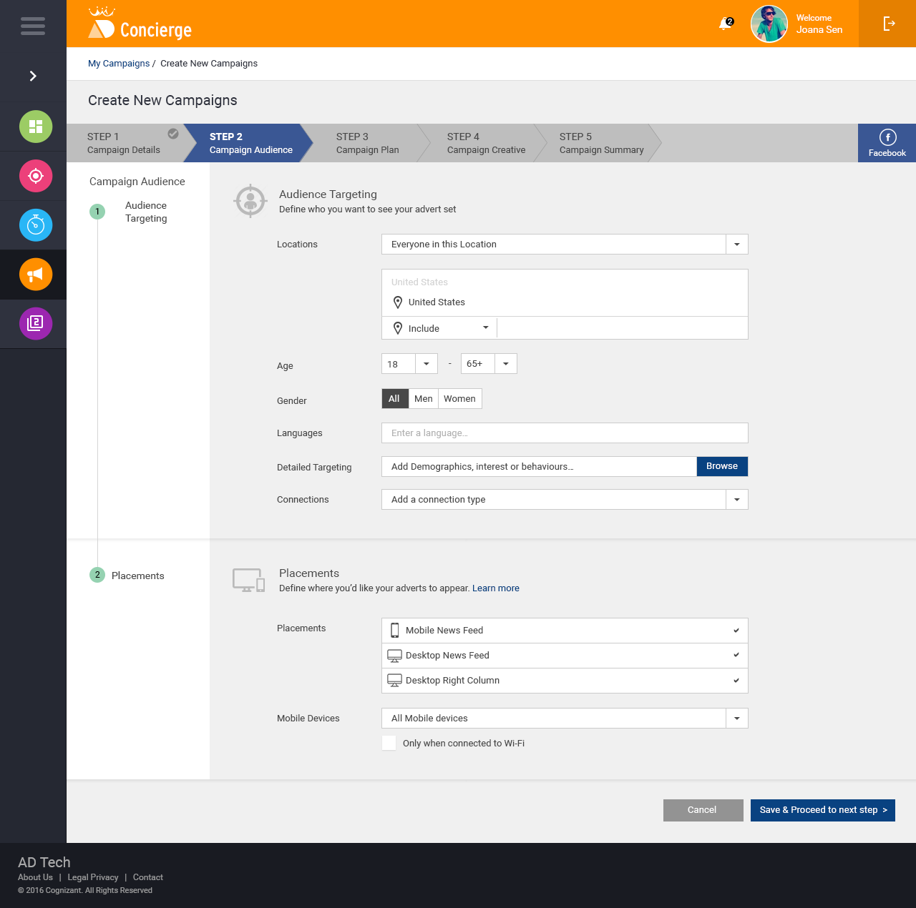

Facebook Plan Page

campaignplan.js
(controller)
Controller)
Request for
Parameter value
ReplicatorParser.js
FB Plan Page
(enabled with lazy loader)

Returns the
Parameter value

replicatorApp.controller("campaignPlanController", ['$rootScope', '$scope', '$http', 'parser', function($rootScope, $scope, $http, parser) {

])

Budget – It is a mandatory field, returned budget value should be converted as per the facebook budget using getCurrencyConversion service and then it will be auto filled in budget field.
Schedule – It is also a mandatory field, This field should show two either or option with values, Run my advert set continuously starting today and Set a start and end date. We should request start date and end date, if parser returns both of the values we should populate both start date and end date otherewise we should populate run my advert ser continuosly option.
Pricing – We should request automatically_select_bid, parser will check if true, it will return true and we should auto fill the first option autobid, if it is false, parser will return bid_amount_local_micro and auto filled the bid amount
Pacing – It is a mandatory field, returned pacing type value will be auto filled in Delivery Type field in facebook.

Var budget = Parser.getParsedObject("budget”);
Var age = Parser.getParsedObject(“age”);
Var isAutoBid = Parser.getParsedObject(“automatically_select_bid”);
Var pacing= Parser.getParsedObject(“deliveryType”);

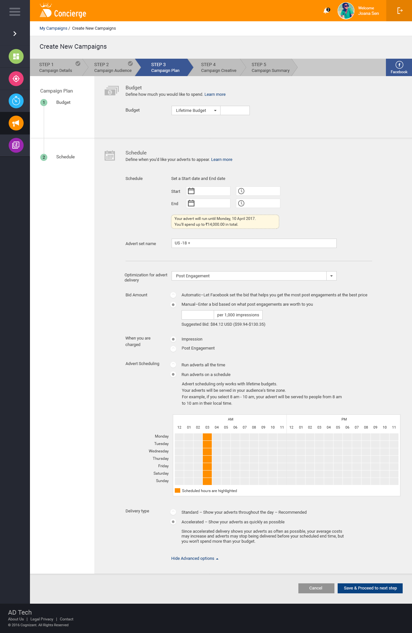

Derived Requirements
    - Replication mode is applicable only on create flow after replication
    - Replication is applicable only for step1, step2 and step3.
    - During the replication process, If user navigating between step1 to step3, the same campaign will be considered as replication flow. If user moves out of campaign replication flow anywhere between step1 to step3 and the same campaign will be considered as normal edit flow, no replication is applicable after that.
    - In all the cases, step 4 will be considered as normal create and edit flow and no replication is applicable for this step.
    - Campaign page rendering will be done via Oclazyloader respectively.
    - Required JS/CSS can able to mix normal boot and load on demand.
    - Replicator is a separate module, we can define our replicator modules as dependencies
var app = angular.module('app', ['ui.router', 'ui.bootstrap', 'ngResource', 'flash', 'login', 'dashboard', 'admindashboard','ngDraggableImage', 'replicator']);

Change Log
Please note that this table needs to be maintained even if a Configuration Management tool is used.
Version Number | Changes made
V1.0 | <First version>
V1.1 | <If the change details are not explicitly documented in the table below, reference should be provided here>
V1.1 | Page no | Changed by | Effective date | Changes effected
V1.2 | <If the change details are not explicitly documented in the table below, reference should be provided here>
V1.2 | Page no | Changed by | Effective date | Changes effected

